Thames International College



Project on Gym Membership and Class Management System

Submitted
In partial fulfillment of degree of Bachelor of Computer Application

Affiliated to
Tribhuvan University

Submitted By: Ipsit Shrestha Pranav Gurung
Submitted To: Pesal Rai Supervisor

CHAPTER: 1
INTRODUCTION

  - Introduction
Gym Membership and Class Management System (GMCS) is aimed at making gym memberships and activities efficient and easier for the users. This system server as a comprehensive tool to help many fitness centers in handling membership data and schedules of their clients efficiently, while also tracking the individuals progress, attendances, member engagement and the overall experience for gym members.

By digitalizing the membership process, the system will simplify the daily operations of fitness facilities, from organizing member schedules, tracking attendance and monitoring the progress of each individuals. This will provide a user-friendly interface that allows members to easily track their memberships, monitor their progress, book appointments, and many more, while also enabling gym administrators to manage all the related tasks with much efficiency and accuracy.

Through this project, we aim to provide a solution that not only improves operational efficiency for fitness centers but also enhances member satisfaction by offering a high quality and modernized membership management experience.

  - Problem Statement
Many gyms and fitness centers face significant challenges in managing their memberships efficiently. The current reliance on manual processes for tracking member data, such as attendance, payment information, and renewals, often results in administrative inefficiencies and a higher risk of errors. Additionally, the lack of a centralized system for storing and organizing member information makes it difficult for staff to quickly access and retrieve necessary data, causing delays and potential dissatisfaction among members. Another key issue is the inability to monitor and track member’s progress effectively, which can negatively impact the member’s experience. Furthermore, the process of managing payments and subscription renewals is often complex, leading to missed payments, billing errors, and confusion for both gym staff and members. Many gyms also fail to provide a seamless user experience, leaving members frustrated when trying to sign up, renew memberships, or track their fitness progress. Tracking individuals progress without any tools is a problem as well as there isn't any proper way of knowing if any trainer has prior appointment or not which can be frustrating for the gym members. A modernized gym management system that can improve operational efficiency and enhance the overall member experience.

  - Objectives
The objectives of this app are as follows:
- To improve gym member and trainer experience in their day to day activities.
- To digitalize gym membership tracking, administrative tasks and progress tracking.

CHAPTER: 2
BACKGROUND STUDY AND LITERATURE REVIEW

2.1 Background Study
It has been found that many existing gym management systems lack comprehensive features for effectively tracking fitness progress. This gap often prevents users from focusing on the specific training and exercises that would optimize muscle development and overall gym progress. GMCS assists the members in keeping track of progress which in turn helps the user to focus on certain training and exercises which is beneficial for better muscle development and gym progress. The trainers are also able to give feed backs and give suggestion to their client after their individual sessions and help them if any needed. Different websites and systems have different features which are very beneficial for the user, though all of those features are not available in a single website or system, that is where GMCS helps the user to make it efficient as well as easier to access all those features in a single system for the ease of usability. The GMCS assists in managing a gym's operations, including overseeing member activities, class schedules, and progress tracking. Traditionally, gym staff have had to handle these task manually, which may lead to issues such as missed appointments, error in membership management and difficulties in tracking member progress. GMCS automates these processes, which reduces the gym staffs and members workload and providing a seamless experience for the users. By digitizing these tasks, GMCS ensures that all necessary operations are handled efficiently, making it easier for staff to keep records updated and for members to stay engaged with their fitness journey.

2.2 LITERATURE REVIEW
Before getting into the development of the system, we thoroughly studied the current practices and available resources within the fitness industry. This study was contributory in creating the roadmap for the system's development. We observed that many gyms still rely on manual paper-work processes to manage memberships, schedules, and payments, which can lead to inefficiencies and errors. We also explored how different gyms currently handle these tasks and identified the areas where the GMCS could offer meaningful improvements.
We also studied existing systems that serve similar purpose as the system. Among them, GymMaster is a gym management software designed to make it easy to maintain detailed records of members and their memberships, book classes and trainers, process and track sales, and communicate with the right members at the right time. It makes it easier for members to book into classes or personal training sessions, update their profile, check in, view workouts and visitation [1]
Zoho Gym Management is another gym management software that allows the management of client memberships and packages, schedule training sessions, track member attendance, and seamlessly process payments. Their gym management software is designed to make it easy to manage and administrate fitness clubs of all sizes. This app is ideal for creating schedules for clients and ensuring that trainers are available. It can track the number of members in various classes and analyze the busiest times of the day to manage trainers' schedules more efficiently. Opening new sessions, monitoring staff availability, rescheduling classes can be done with their simple drag and drop interface. [2]
Zen Planner is also a system with member attendance and skill tracking, interactive online calendar, reminder and email templates, they have everything it takes to grow and maintain the fitness community members have created. It has a helpful dashboard and reporting tools keep you informed as to how users business is doing and one can instantly access membership data from anywhere. It focuses on helping fitness businesses manage memberships, schedule classes, and automate administrative tasks. [3]
Mindbody is also another system has features like appointment scheduling, membership management, staff management, client app for booking, automated marketing tools, and payment processing. It has a comprehensive suite of tools that serve fitness centers, wellness businesses, and gyms, along with robust marketing and client engagement features. It has a user-friendly interface, strong customer support, integrations with third-party apps. [4]

CHAPTER: 3
SYSTEM ANALYSIS AND DESIGN

3.1 System Analysis
This system is designed with the series of processes starting with research, planning, design, development, testing and debugging. During research, all the functional and nonfunctional requirement are analyzed and system is developed according to the requirement then designing of the system is carried out. After the planning and design process, coding and development part is started then after integrating the system there is testing of the system. If the testing is positive then system is implemented otherwise some debugging is done and system comes to operation.

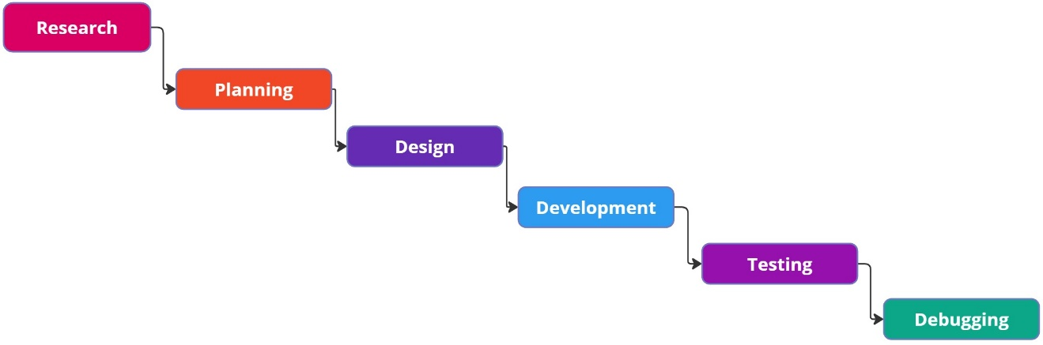

Fig 3.1: Waterfall Model for Gym Membership and Class Management System

3.1.1 Requirement Analysis
The requirements are to be collected before starting projects' development life cycle. To design and develop system, functional as well as non-functional requirement of the system has been studied.
  - Functional Requirement
Different functional requirements of the system have been identified and have been listed below:

For Administration:
- The admin should be able to create, edit and delete gym membership plans.
- The admin should be able to create and manage class schedules, including assigning trainers and defining time slots.

For Trainers:
- Trainers should be able to create and manage their profiles, including uploading qualifications, schedules, and specialty areas.
- Trainers should be able to view their assigned classes, member enrollments, and attendance records.
- Trainers should be able to track individual member progress.
- Trainers should be able to manage their personal schedules and update their availability for training sessions or classes.

For Gym Members:
- Gym members should be able to create an account and sign up for a membership plan.
- Gym members should be able to browse available classes, view class schedules, and register for classes online.
- Gym members should be able to track their workout progress, and monitor their progress.

3.2 USECASE DIAGRAM
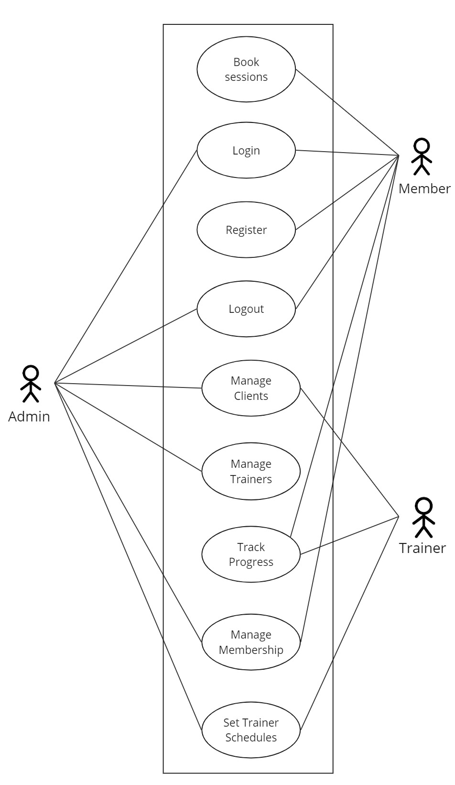
In Gym Membership and Class Management System, there are three actors such as admin, trainer and member where admin can login, manage staff and members, and logout from the admin panel. Likewise, gym members can register, login, select a trainer and book their session, track their progress and logout from the system. Lastly, trainers can register, login, set their schedules, and track the progress of their clients and logout from the system.

Figure 3.2: Use Case Diagram of Gym Membership and Class Management System
  - Non Functional Requirement
Different non-functional requirements of the system have been identified and have been listed below:
- Security: The system is secure from outside attacks as only authorized users and admins are allowed to access the data. This system also uses at least 8-character passwords for security. Different validation processes are used.
- Performance: The performance of the system is fast and accurate as in this system database is normalized so it provide fast operations.

3.3 Feasibility Analysis
The feasibility study concluded that the project is able to be implemented to success as it was carefully planned.

- Technical Feasibility Study
The system is technically feasible as the requirement for the development of the system is easily accessible. The necessary hardware and software required for the development and implementation of the system is available. The basic programming language which is suitable for project is available and the libraries required for project is capable of achieving the result that we are aiming for. All the resources need for development of the system are already available.

- Operational Feasibility Study
The system is easy to operate with the basic knowledge of computer and internet, and well trained manpower is not necessary. Users can also easily access the system as it is user friendly in many aspects with good User Interface (UI). This system include all the requirements used for the gym management system and this system is completely operational and can be successfully implemented and the administration can easily use this system as it is user-friendly.

- Economic Feasibility Study
The system is economically feasible and cost effective. As all the tools and resources required are either open sources or free. After the completion of the system, the organization didn't need to deploy any new hardware and software as the required software and hardware already exist.

- Schedule Feasibility
The system can be completed within the scheduled time.

Fig 3.3.1: Gantt chart Table for Gym Membership and Class Management System
Task Name | Duration
Research | 1 Week
Planning | 1 Week
Designing | 1 Week
Development | 6 Weeks
Testing | 3 Weeks
Debugging | 1 Week
Documentation | 12 Weeks

Fig 3.3.1: Gantt chart for Gym Membership and Class Management System
3.4 System Flowchart

For Admin
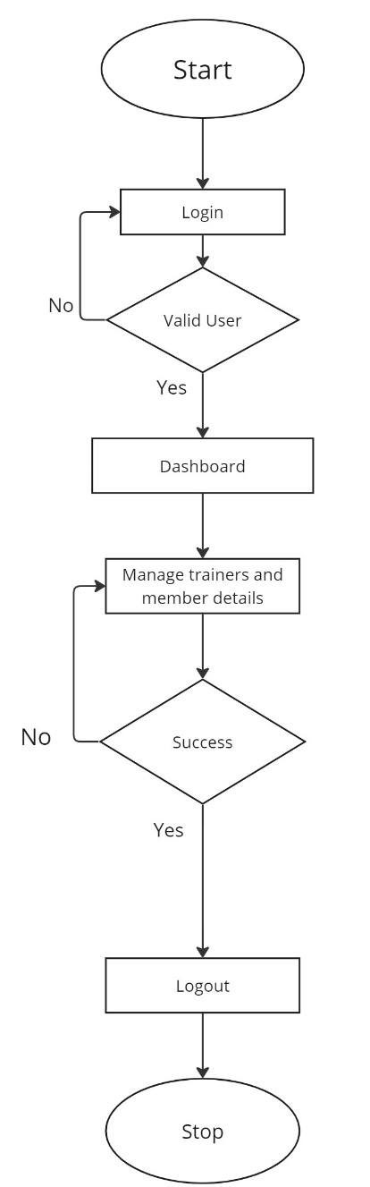
Fig 3.4.1: Flowchart of Gym Membership and Class Management System for Admin

For Trainer
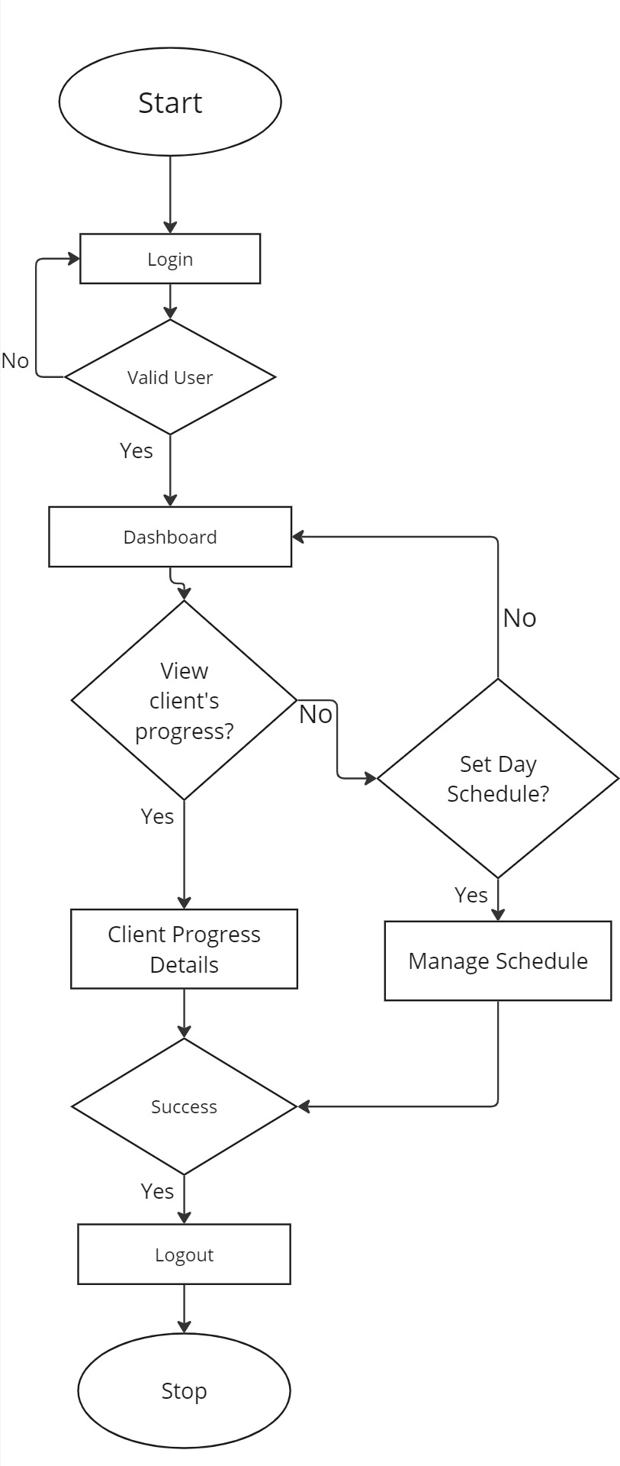
Fig 3.4.2: Flowchart of Gym Membership and Class Management System for Trainer

For Member
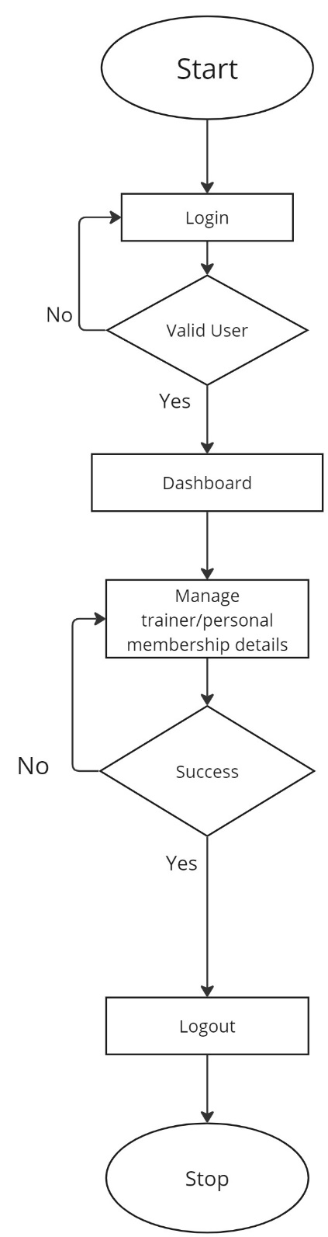
Fig 3.4.3: Flowchart of Gym Membership and Class Management System for Member

Expected Outcome
The Gym Membership and Class Management System will bridge the gap between gym members and efficient management of their fitness journey. The system should allow users to:
    - Manage member information, scheduling, and progress tracking.
    - Reduce time and effort required for both staff and members.
    - Enable admins and trainers to manage their clients more efficiently.

REFERENCES

[1] | [Online]. Available: https://www.gymmaster.com/.
[2] | Z. G. Management. [Online]. Available: https://www.zoho.com/creator/apps/gym-fitness-management-software.html.
[3] | Z. Planner. [Online]. Available: https://zenplanner.com/.
[4] | M. Software. [Online]. Available: https://www.mindbodyonline.com/.
[5] | J. G. J. V. Jafferey A. Hoffer, in Modern System Analysis and Design, 6 ed., Prentice Hall India.
[6] | L. B. Jeffery Whitten, in System Analysis and Design Methods, 7 ed., McGraw-Hill.

